Camp Name:
Location:
Camp Start Date:
Camp End Date:
Total # of Students:
Total # of Scholarship Students:
Grade Levels:

Academic Feedback:
Innovative Activities:
Curriculum Used: |  | Check all that apply:  ☐ iReady Reading  ☐ Moby Max  ☐ Success Maker  ☐ Paper online tutoring  ☐ School District of Palm Beach County’s L.I.T. Summer  Curriculum  ☐ Provider specific curriculum  ☐ Other (please provide additional information below):
Outcome by Grade Level:
Academic Accomplishments:
Teacher’s Feedback:
Academic Challenges:
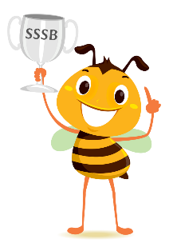 | Did your camp participate in the Super Summer Spelling Bee? |  | ☐ No | ☐ Yes
 |  |  | If no, why not?

(Please provide photos via email of your campers in action)

